1. Find the rollback equilibrium of the game as depicted by the tree –

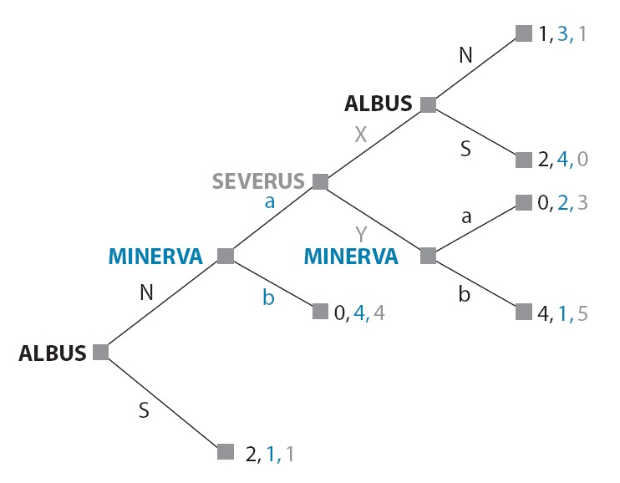

1. Which one is the IEDS (iterated elimination of dominated strategies) solution for the following game depicted by the payoff matrix?

|  |  |  |  |  |  |
| --- | --- | --- | --- | --- | --- |
|  | | **Colin** | | | |
| North | South | East | West |
| **Rowena** | Earth | 1, 3 | 3, 1 | 0, 2 | 1, 1 |
| Water | 1, 2 | 1, 2 | 2, 3 | 1, 1 |
| Wind | 3, 2 | 2, 1 | 1, 3 | 0, 3 |
| Fire | 2, 0 | 3, 0 | 1, 1 | 2, 2 |

1. Find the Nash equilibrium (e*quilibria*) of the game described in question 2.
2. An old lady is looking for help crossing the street. Only one person is needed to help her; if more people help her, this is no better. You and I are the two people in the vicinity who can help; we have to choose simultaneously whether to do so. Each of us will get pleasure worth a 3 from her success (no matter who helps her). But each one who goes to help will bear a cost of 1, this being the value of our time taken up in helping. If neither player helps, the payoff for each player is zero. Write the payoff table, and find the pure-strategy Nash equilibrium (equilibria).